1. Write a shell script to generate the series of even number from 0 to n. 0 2 4 n

Ans:

clear

echo "enter value of n"

read n

i=0

while test $i -le $n

do

printf " $i"

i=`expr $i + 2`

done

echo

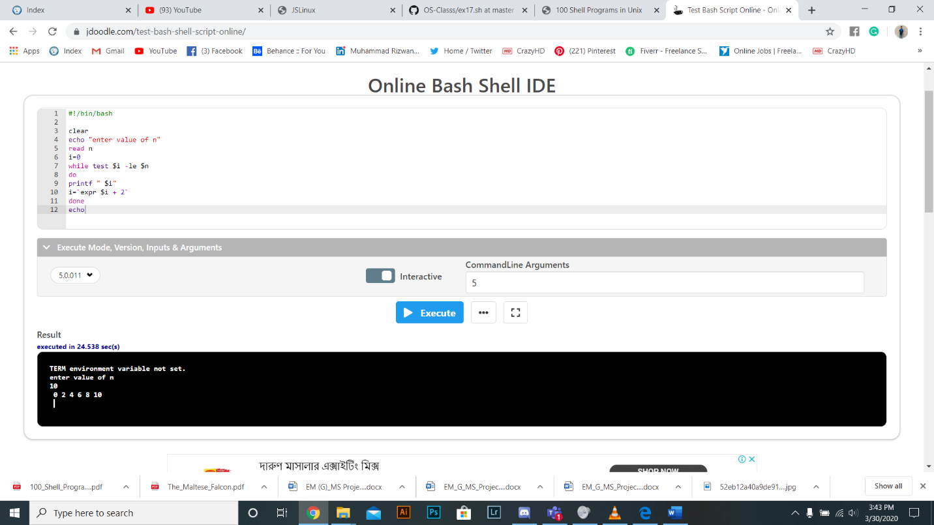

1. Write a shell script to find out the sum of series 1+2+3+.............n, where n is input by the user.

Ans:

clear

echo "enter value of n"

read n

i=1

sum=0

while test $i -le $n

do

sum=`expr $sum + $i`

i=`expr $i + 1`

done

echo Sum of series is $sum

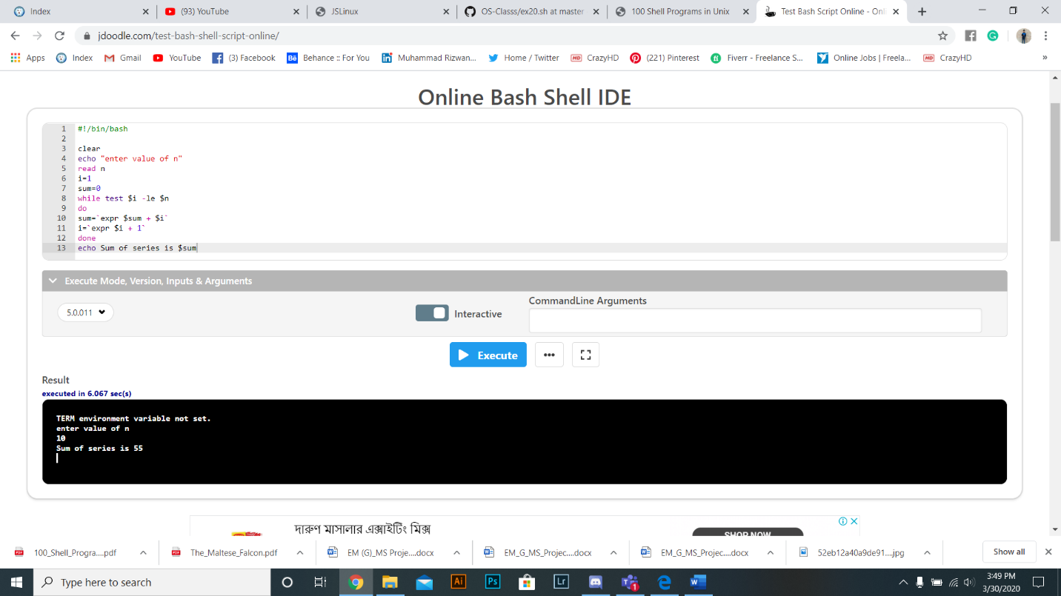

1. Write a shell script to print the characters of an input string into reverse order.

Ans:

x="welcome"

len=`echo ${#x}`

while [ $len -ne 0 ]

do

y=$y`echo $x | cut -c $len`

((len--))

done

echo $y

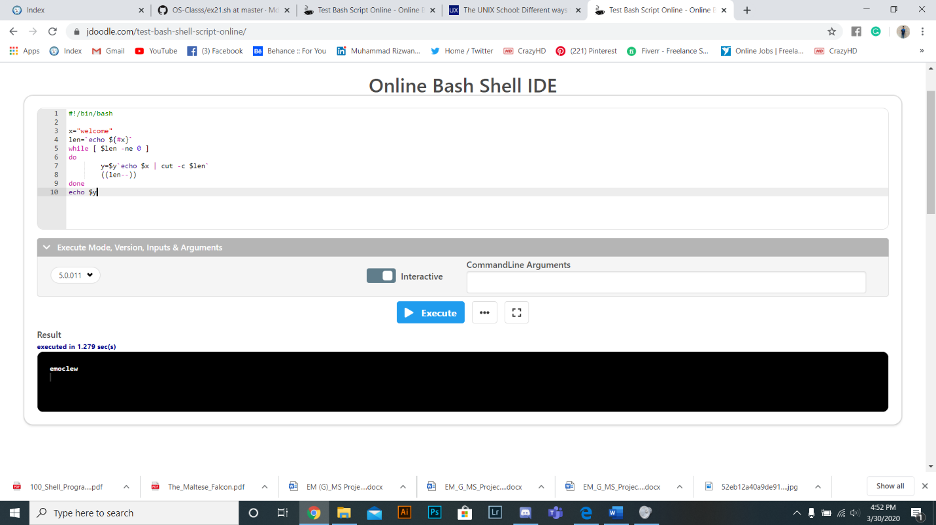

1. Write a shell script to count the number of characters, words, spaces in a given text.

Ans:

echo Enter a text

read text

w=`echo $text | wc -w`

w=`expr $w`

c=`echo $text | wc -c`

c=`expr $c - 1`

s=0

alpha=0

j=` `

n=1

while [ $n -le $c ]

do

ch=`echo $text | cut -c $n`

if test $ch = $j

then

s=`expr $s + 1`

fi

case $ch in

a|b|c|d|e|f|g|h|i|j|k|l|m|n|o|p|q|r|s|t|u|v|w|x|y|z) alpha=`expr $alpha + 1`;;

esac

n=`expr $n + 1`

done

special=`expr $c - $s - $alpha`

echo Words=$w

echo Characters=$c

echo Spaces=$s

echo Special symbols=$special

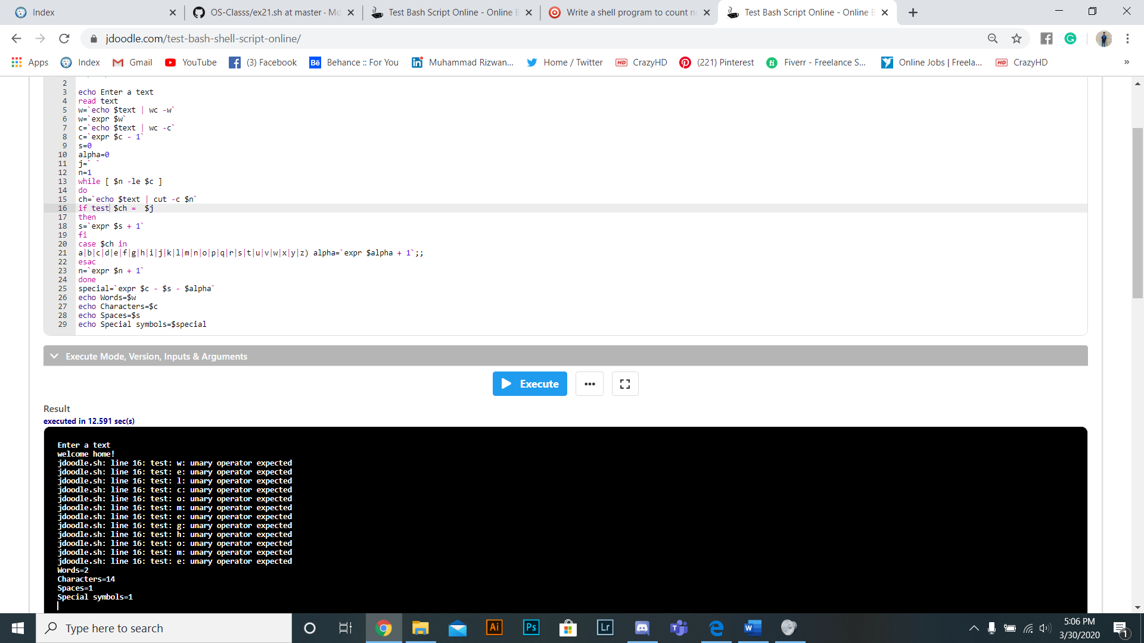

1. The marks obtained by a student in two different subjects are input through the keyboard. The student gets a division as per the following rules. (Using elif clause). If percentage greater than or equal to 60 get First division if percentage greater than or equal to 50 or less than 60 get Second division if percentage greater than or equal to 40 or less than 50 get Third division if percentage less than 40 Fail

Ans:

echo "Enter the five subject marks for the student"

read m1 m2 m3 m4 m5

sum1=`expr $m1 + $m2 + $m3 + $m4 + $m5`

echo "Sum of 5 subjects are: " $sum1

per=`expr $sum1 / 5`

echo "Percentage: " $per

if [ $per -ge 60 ]

then

echo "You get Distinction"

elif [ $per -ge 50 ]

then

echo “You get First class”

elif [ $per -ge 40 ]

then

echo "You get Second class"

else

echo "You get Fail"

fi

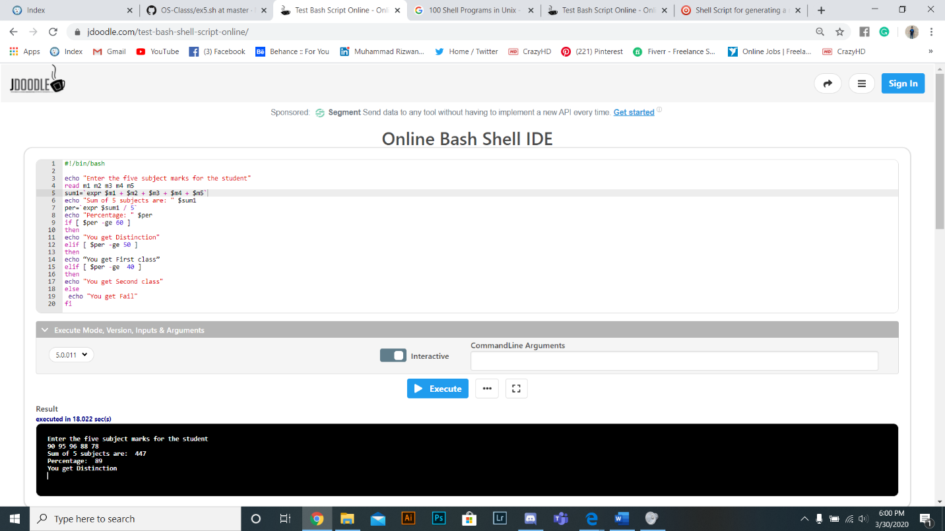

1. Write a shell script to search a file in current directory.

Ans:

clear

echo Enter a file name to search

read fn

ls | grep $fn>/dev/null

if [$? -eq 0]

then

echo The file $fn is present in the current directory.

else

echo The file $fn is not present in the current directory.

Fi

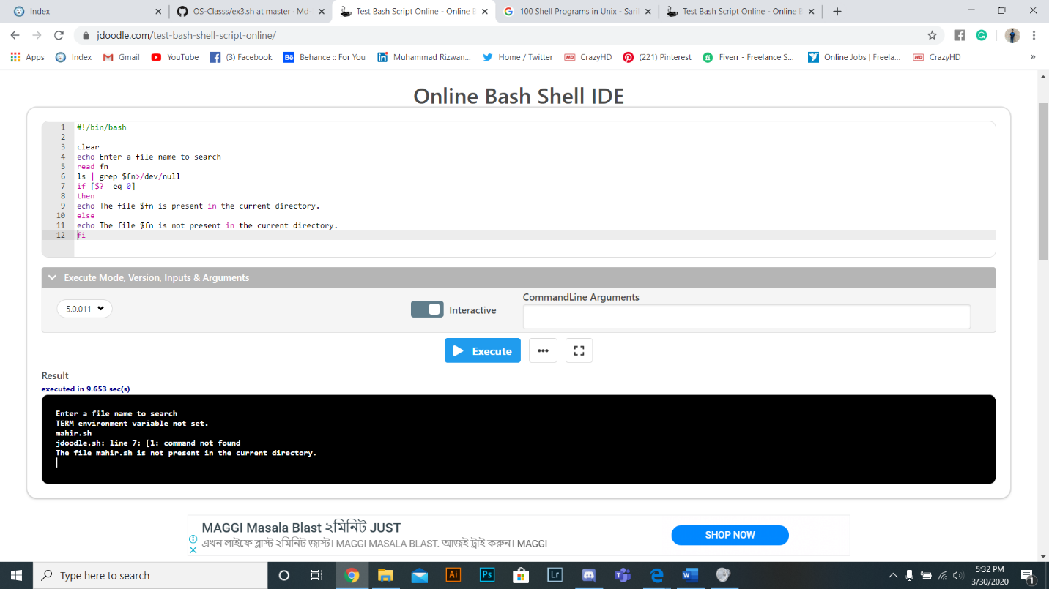

1. Run All grep command

Ans:

$ cat /proc/cpuinfo | grep 'vendor' | uniq

$ cat /proc/cpuinfo | grep 'model name' |

$ cat /proc/cpuinfo | grep processor | wc -l

$ cat /proc/cpuinfo | grep 'core id'